Agency for electronic communications
in Republic of Macedonia
is organizing:
2 nd Meeting on RTTE/RED
15-16 May 2018
In Metropol Lake Resort - Ohrid

Rates for stay: Double occupancy Single occupancy
h. Metropol or h.Bellevue 35 € 49 €

* rates are given per person per night, Bed & Breakfast and all local taxes included;

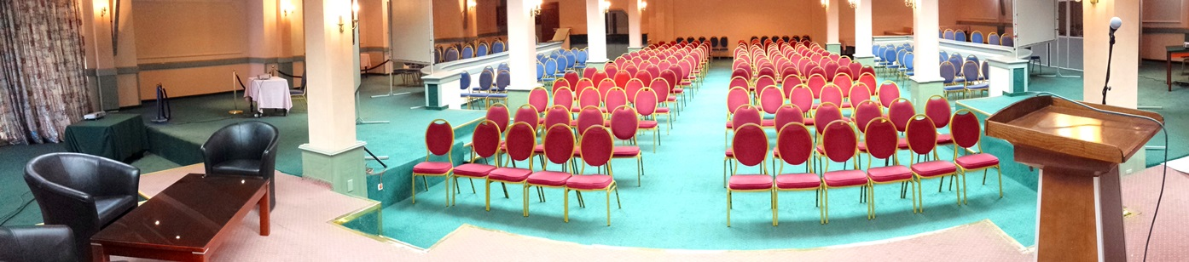

Hotel Reservation Form:
(please send the filled request for a booking by 20th April 2018)

Hotel: |  | Check In & Check Out dates:
Room occupancy:
Gues name(s):
Organization / Company name & contact details (phone / e-mail)

Method of payment (please choose one):

1) At Reception desk during the stay (cash or credit card);
2) Bank transfer, by 10 ^{th} May 2018 (we’ll send you a pro form Invoice with our details)

Please send the filled Reservation Form to the Hotel and CC to Organizer (AEC):

Е-mail: sales@metropol-ohrid.com.mk & CC то: Dragica.Lepavcova@aec.mk
Tel: 046 203 001
Fax: 046 277 212
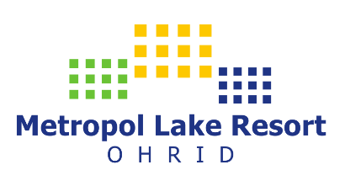
http://www.metropol-ohrid.com.mk

* reservation is only valid with written conformation from the Hotel.

